AGRICULTURAL SEEDS’ SOVEREIGNTY IN AGRO-ECOLOGICAL BELTS OF MECHI ZONE, NEPAL
Madan Chudal, Man Kumar Dhamala (PhD)
Abstract
Seed’s sovereignty is the foundation of food security, including availability, accessibility and community-based control over agricultural seed resources. The study investigated the state of seeds sovereignty for the three major cereals crops Oryza sativa, Zea mays, Triticum aestivum in the different agro- ecological belt of Mechi Zone, eastern Nepal through Rapid Rural Appraisal (RRA) such as focal group discussion, key informant interview, Structured questionnaire survey (N=240), along with secondary data from Nepal Agriculture Research Council (NARC), Department of Hydrology and Meteorology (DHM) data analyzed with Mann Kendall trend test, household level seeds inventory analyzed using t-test, Wilcoxon test and ANOVA R Studio. Thirty-year Mann-Kendall analyses of meteorological records (1987-2016) showed statistically significant rising temperature (Sen's slope: +0.027 to +0.109°C/yr) and negative rainfall trends during all cropping seasons, underpinning climate change as an underlying force of improved variety adoption. Seed Replacement Rates (SRR) were high across all study sites, with traditional rice seeds entirely replaced in Arjundhara Municipality (Terai), while traditional maize and wheat sovereignty remained in high-elevation study sites only (Yangworak, Phungling, and Aathrai Rural Municipalities). Seeds accessibility was sufficient across all belts but not enough for ensuring seed sovereignty. Community seed banks were identified as a pivotal institutional support for traditional seed sovereignty. The findings offer evidence-based insights for guiding seed conservation policy, climate adaptation planning, and food sovereignty strategies in Nepal and similar South Asian Mountain agroecosystems.

Keywords: Seed Sovereignty, agro-ecological belts, climate variability, traditional seeds, modern seeds.
Introduction
Background
Seed sovereignty refers to the farmer’s ownership over the seeds through local sustainable production and distribution (Adhikari, 2014).

(Gauchan et al., 2005) illustrates that the landraces varieties of seeds are traditional and culturally valuedand are still conserved and cultivated in most part of Nepal. However,Hybrid seeds and genetically modified seeds were introduced in Nepal after the agreement between Government of Nepal and USA multinational company, Monsanto in 2011, with the intention of improving food security and enhancement of income of Nepalese farmers (Adhikari, 2014)

The research focuses on the status of cereals like rice, maize and wheat in agro-ecological belts of Mechi Zone, Nepal. The study aims to examine the factors that led to the shift from traditional to modern agricultural seeds, determining the connection between climatic factors and the growing dependence on modern varieties, and finally evaluating the ensuing implications for seed security, this study seeks to understand the phenomenon.

Nepal has different agro- ecological belts with variable climates. The production of crops is directly related to climatic stress and depends on the monsoon. The variability of temperature and rainfall shows adverse impact on production (D, 2017). The major challenges during the plantation of crops include the changes in timing of rain-fed rice cultivation and irrigation problem due to drying up the water resources (Devkota, 2014).

The farmers own innovative knowledge of traditional seeds selection enhances the adaptability to the local situation. The traditional seeds producing area could be a healthy environment without any biotic and abiotic stress (Thomas et al., 2011). The effective participation of farmers for the conservation of crops plants on the farm involves the in – situ conservation. The promotion of local diversity could secure rights of people on traditional agro- seeds diversity (Jarvis et al., 2011).
The conservation of plant genetic resources, at the community level enhances the seed security. To conserve the traditional seeds is the farmers‟ rights, involves the decision making and sharing of benefit regarding the food sovereignty, and community resilience (Porcuna-Ferrer et al., 2020).

……………………………………….
Nepal is agricultural country in which agriculture accounted for 36.64% of gross domestic product (GDP) in 2005/06 and despite falling to 33.1% by 2014/15, has gross domestic product of US$21.14 in 2016 and gross national income (GNI) of US$730 per capita being agriculture the largest sector of the economy (Pradhan & Zellmann, 2018). Commercialization of biotech crops had come in practiced from 1996 A.D in which global area of biotech crops increased up to 94-folds, covering 1.7 million hectares in 1996 to 160 million hectares in 2011. The rate of adoption of biotech seeds increased drastically in 2011. About 15.4 million farmers in twenty nine countries were planted 148 million hectares of land in 2010 and 16.7 million farmers planted 160 million hectares of land from same number of countries in 2011A.D (James, 2011).----------clear
The introduction of improved varieties has increased rate of productivity. The increased productivity is the economic source for farmers and improving crops with new technology is the option to rid food insecurity (Sunitha et al., 2025).
The modern agricultural seed needs the use of chemical fertilizers and pesticides for food production. The extensive use of improved varieties and import of modern agricultural seeds from foreign nation results the abandonment of traditional agricultural seeds. It has been raising the question of seeds insecurity, environmental impact of modern seeds and imbalance of environmental economic to the farmers. The research focuses on the status of cereals like paddy, and wheat in agro-ecological belts of Mechi Zone, Nepal. The research aims to explore the reason behind the abandonment of traditional agricultural seeds and introduction of modern seeds and status of seeds security in agro-ecological belts of eastern Nepal.
Seeds sovereignty is defined similar to the food sovereignty. The gradual loss of traditional seeds of major crops rice (Oryza sativa), maize (Zea mays), and wheat (Triticum) leads the seeds scarcity to the farmers at the local level. The concept of seeds sovereignty has been raised to provide food security through local sustainable production and distribution (Adhikari, 2014). The landraces varieties of seeds are traditional and culturally valued and Landraces rice varieties such as Lalka Basmati, Kariyakamod, Kanakjira in Bara district, Kalo Nuniya in Jhapa, Jetho budho, Jhinuwa and Pahenle in Kaski, Gudgudo in Gulmi and Gude (kalo and Seto) in Dailekh are still conserved and cultivated (Gauchan et al., 2005). ------clear
Maize is second preferred food cultivated in the different agro-ecological belts including Terai and inner Terai, Mid-hill and Mountains of Nepal. The major traditional maize varieties of eastern mid hill include Seto Chepti, Pahelo, Kalo, kukhure. The central and western hill of farmers have local pahelo, Seto Chepte muruli. Similarly, mid and farmers of far-western mid hill have Thulo, Nano and Maradi local maize seeds (MOAD, 2015) ---- clear
After the 1950s, wheat breeding process began in Nepal with Indian varietal trials. The improved varieties like RR 21, Triveni, Vinayak etc were preferred by farmers in Terai during the decades of 1990s and varieties introduced in mid hills is Lerma 52 called Mexican varieties. Although, the released of improved varieties small portion of mid-hills is still planted tall varieties (Morris, 1994). ------ Clear
The production of crops is directly related to the climatic stress and depends on the monsoon. Delayed of monsoon has already been impact on wheat (Achhami et al., 2015). The raising of temperature shows the significant impacts on the moisture and nutrients level of soil through rapid evapo– transpiration, soil erosion, and landslides (Synnott, 2012). ------- Clear
Two major challenges during the plantation of crops include the changes in timing of rain-fed rice cultivation and irrigation problem due to drying up the water resources (Devkota, 2014)------Clear
International Protocol on Climate Change (IPCC) pointed, in 20th century, the precipitation rate has increased from 5% to 10% over mid and high latitudes of northern hemisphere continents but has decreased by 3% on average in much of sub-tropical. Frequency of extreme weather events like prolonged dry season was appeared in several regions (Parry et al., 2010).-------Clear
In northern areas climate change may produce positive effects on agriculture through introduction of new crop species and varieties, higher crop production and expansion of suitable areas for crop cultivation (Olesen and Bindi, 2002).------Clear
Total 11 spring season (Chaite season) modern rice seeds are released. The rice varieties are release on the basis of season characteristics. Total 62 modern rice seeds released for main season cropping and 11 varieties are release for spring season (Chaite season). The improved rice varieties have comparatively higher productivity than traditional varieties. The higher the productivity of rice varieties have the more economic benefits to the farmers (MOAD, 2015).---- Clear
NARC has developed total 30 varieties of maize. Total five varieties were hybrid including Rampur Hybrid-2, Rampur Hybrid-4, Rampur Hybrid-6, Gaurab, and Khumal Hybrid-2. Total 49 wheat varieties released since 1960 and 11 varieties currently popular in country (NARC, 2017).----- Clear
Commercialization of biotech crops had come in practiced from 1996 A.D in which global area of biotech crops increased up to 94-folds, covering 1.7 million hectares in 1996 to 160 million hectares in 2011. The rate of adoption of biotech seeds increased drastically in 2011. About 15.4 million farmers in twenty nine countries were planted 148 million hectares of land in 2010 and 16.7 million farmers planted 160 million hectares of land from same number of countries in 2011A.D (James, 2011).------ Clear

Materials and methods
The study was carried out in all ecological belt of Koshi Province comprising Taplejung district of Himalayan region, Panchthar and Ilam districts of Hilly region and Jhapa district of Terai region (Figure 1).

Jhapa, Ilam, Pancthar and Taplejung districts of Koshi Province, comprising all ecological belts of eastern Nepal. Jhapa is terai district, Ilam and Panchthar districts lies in Hilly region and Taplejung lies in Himalaya region. Climatic pattern of these four districts ranges from tropical to alpine. These four districts boarders to the India in south (Jhapa district) and east (Jhapa, Ilam and Panchthar districts) and to China in North (Taplejung district).
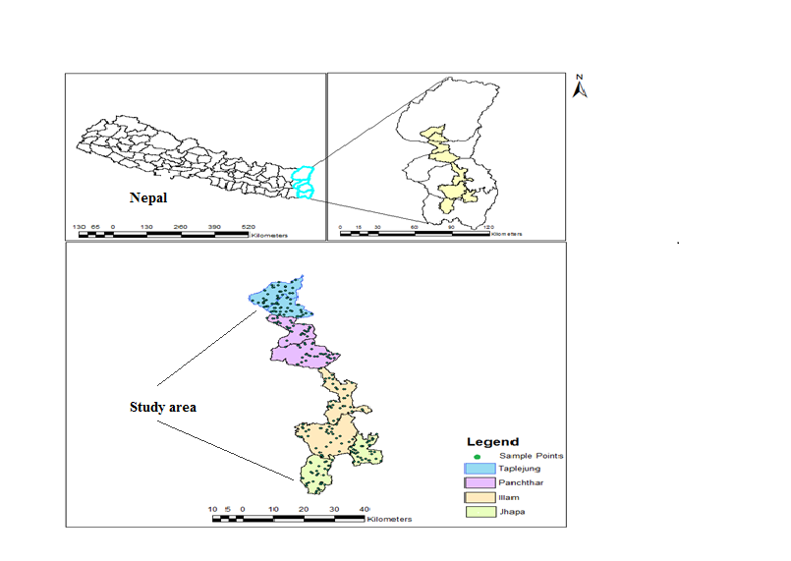
Figure 1: Agro-ecological belt of Mechi Zone
Methodology: Seeds’ sovereignty and seed security are based on Seeds security conceptual framework (SSCF) of seeds availability, seeds accessibility and varietal suitability (FAO, 2015). ------ Clear
Primary data were collected through Rapid Rural Appraisal (RRA) such as focal group discussion (FGD), key informant interview (KII), agro-vet, community agricultural promotion center, field observation on farmer’s experiences. Structured questionnaire were used for household survey to get information to full fill the objectives of the research. Random households were selected by GPS to identify the points. The total sample size was 240 and thirty respondents were selected from each study site. Secondary data were obtained from published literature of provided by District Agricultural Development Office (DADOs). The climatic data were obtained from Department of Hydrology and Meteorology.
Data analysis: Primary data were analyzed using tests such as t-test, Wilcox test and ANOVA using R-Core team and MS Excel. Climatic data such as rainfall and temperature were analyzed with Mann-Kendall test. For non-parametric statistical trend test, Mann-Kendall is widely used for the analysis of trend in climatologic (Mavromatis, 2011) and hydrologic time series (Yue&Wang,2004) ------ clear

Results
The abandonment of local seeds of paddy was found mainly due to lack of productivity (40%) followed by poor conservation practices (34%). People’s perception for abandonment of local seeds of maize and wheat was contrary to paddy, mostly due to poor commercialization followed by lack of productivity. The relationship between abandonment of local seeds and factors causing abandonment is statistically significant (Chi square=22.79, df=4, p=0.0014). In figure (2) almost 40% respondents have clear reason for loss of traditional rice varieties due to lack of productivity, 34% respondents advocate lack of conservation and 26% respondents have reason of commercialization of agricultural. Abandonment of traditional seeds is found to be statistically different (Chi square=22.79, df=4, p=0.0014).

Figure 2: Factors causing replacement of traditional seeds
In figure (2) almost 40% respondents have clear reasons for loss of traditional maize varieties due commercialization, 37% respondents have opinion of lack of productivity, and 23% respondents have reason due lack of conservation of traditional seeds. Similarly, 45% of respondents have clear reason for loss of traditional wheat varieties due to commercialization of agricultural, 33 % have reason of lack of productivity and 22% respondents advocate lack of inappropriate conservation.

Figure 3: Shifting period of plantation based on people’s perception.
Trend of Climate Variability: The rainfall and temperature data of hydro-meteorological stations from four districts have shown the gradual change in the trend of both rainfall and temperature. Data shows the decreasing trend of rainfall in all four districts however, rainfall trend in period of June to September and December to March of Ilam and Panchthar districts are only significant (P<0.05). Average maximum and minimum temperature of the four districts are in increasing trend except average minimum temperature of Ilam district and in period of March to May of Jhapa district, which shows decreasing trend. The increasing trend of average maximum temperature is significant (P<0.05) except in period of December to March of Jhapa and March to May of Jhapa and Ilam. However, average minimum temperature of Taplejung district is increasing significantly in all periods.

District | Period | Parameters | Mann kendall Sen’s slope | Test Kendall’s tau | P-Value | Alpha | Pattern of Change
Jhapa | June to September | Average maximum temperature | 0.045 | 0.441 | 0.001 | 0.05 | Increased
Jhapa | June to September | Average minimum temperature | -0.002 | -0.046 | 0.734 | 0.05 | Increased
Jhapa | June to September | Rainfall | -15.244 | -0.191 | 0.145 | 0.05 | Decreased
Jhapa | December to March | Average maximum temperature | 0.024 | 0.164 | 0.211 | 0.05 | Increased
Jhapa | December to March | Average minimum temperature | 0.008 | 0.039 | 0.775 | 0.05 | Increased
Jhapa | December to March | Rainfall | -1.8 | -0.246 | 0.058 | 0.05 | Decreased
Jhapa | March to May | Average maximum temperature | 0.028 | 0.194 | 0.138 | 0.05 | Increased
Jhapa | March to May | Average minimum temperature | -0.015 | -0.098 | 0.464 | 0.05 | Decreased
Jhapa | March to May | Rainfall | 2.071 | 0.099 | 0.457 | 0.05 | Decreased
Ilam | June to September | Average maximum temperature | 0.109 | 0.61 | <0.0001 | 0.05 | Increased
Ilam | June to September | Average minimum temperature | -0.033 | -0.35 | 0.007 | 0.05 | Decreased
Ilam | June to September | Rainfall | -26.046 | -0.416 | 0.001 | 0.05 | Decreased
Ilam | December to March | Average maximum temperature | 0.068 | 0.318 | 0.015 | 0.05 | Increased
Ilam | December to March | Average minimum temperature | -0.056 | -0.27 | 0.038 | 0.05 | Decreased
Ilam | December to March | Rainfall | -2.38 | -0.297 | 0.022 | 0.05 | Decreased
Ilam | March to May | Average maximum temperature | 0.053 | 0.224 | 0.087 | 0.05 | Increased
Ilam | March to May | Average minimum temperature | -0.038 | -0.207 | 0.112 | 0.05 | Decreased
Ilam | March to May | Rainfall | -0.032 | -0.002 | 1 | 0.05 | Decreased
Panchthar | June to September | Average maximum temperature | 0.071 | 0.52 | 0 | 0.05 | Increased
Panchthar | June to September | Average minimum temperature | 0.019 | 0.286 | 0.036 | 0.05 | Increased
Panchthar | June to September | Rainfall | -10.96 | -0.402 | 0.002 | 0.05 | Decrease
Panchthar | December to March | Average maximum temperature | 0.093 | 0.439 | 0.001 | 0.05 | Increased
Panchthar | December to March | Average minimum temperature | 0.055 | 0.286 | 0.034 | 0.05 | Increased
Panchthar | December to March | Rainfall | -2.742 | -0.398 | 0.002 | 0.05 | Decrease
Panchthar | March to May | Average maximum temperature | 0.101 | 0.479 | 0 | 0.05 | Increased
Panchthar | March to May | Average minimum temperature | 0.035 | 0.229 | 0.093 | 0.05 | Increased
Panchthar | March to May | Rainfall | -2.735 | -0.228 | 0.081 | 0.05 | Decrease
Taplejung | June to September | Average maximum temperature | 0.071 | 0.69 | <0.0001 | 0.05 | Increased
Taplejung | June to September | Average minimum temperature | 0.027 | 0.401 | 0.002 | 0.05 | Increased
Taplejung | June to September | Rainfall | -2.142 | -0.044 | 0.75 | 0.05 | Decrease
Taplejung | December to March | Average maximum temperature | 0.106 | 0.589 | <0.0001 | 0.05 | Increased
Taplejung | December to March | Average minimum temperature | 0.036 | 0.274 | 0.035 | 0.05 | Increased
Taplejung | December to March | Rainfall | -3.029 | -0.287 | 0.026 | 0.05 | Decrease
Taplejung | March to May | Average maximum temperature | 0.088 | 0.575 | <0.0001 | 0.05 | Increased
Taplejung | March to May | Average minimum temperature | 0.036 | 0.323 | 0.013 | 0.05 | Increased
Taplejung | March to May | Rainfall | -0.35 | -0.039 | 0.777 | 0.05 | Decrease

Table 1: Trend of climate variability.
Indicators of Seeds Security
Seeds availability: The study shows varying local seed stock with ecological belts. There is significant difference in the stock of local and improved paddy seeds (p<0.05). Stock of improved seeds is found dominating in Shivasatakshi municipality (t=-27.14, p<0.05) of Jhapa district, Ilam municipality (t=-19.18, p<0.05) of Ilam district, Phidim municipality (t=-1.98, p<0.05) of Panchthar district and Aathari Triveni rural municipality (t=7.6, p<0.05) of Taplejung district.
Districts | Municipalities | t-value | Mean difference | P-Value
Stock of Rice Seeds
Jhapa | Shivasatakshi Municipality | -27.14 | -62.67 | <0.05
Ilam | Mai Municipality | 5.13 | 13.33 | <0.05
Ilam | Ilam Municipality | -19.18 | -27.5 | <0.05
Panchthar | Phidim Municipality | -1.98 | -1.77 | 0.028
Panchthar | Yangworak Municipality | 12.48 | 40.67 | <0.05
Taplejung | Phungling Municipality | 10.83 | 31.5 | <0.05
Taplejung | Aathari Triveni Rural Municipality | 7.6 | -11.17 | <0.05

Table 2: Analysis between stock of local and modern rice seeds
Seeds accessibility: Figure 4 represents the accessibility of rice seeds quantitatively maximum in study household of Arjundhara Municipality and Shivasatakhsi Municipality and minimum in Phidim Municipality. Aathrai Rural Municipality and Mai Rural Municipality have quantitatively similar accessibility and comparatively less accessibility status in Ilam Muncipality, Yangworak Rural Municipality and Phungling Municipality. Figure 5 show quantitatively more accessibility of maize seeds is available in Mai Rural Municipality. Study household of Shivasatakshi Municipality, Aathrai Rural Municipality and Ilam Municipality have quantitatively less seeds accessibility through social network compared to individual household seeds accessibility in Arjundhara Muncipality, Phidim Municipality, Phungling Municipality and Yangworak Rural Municipality.
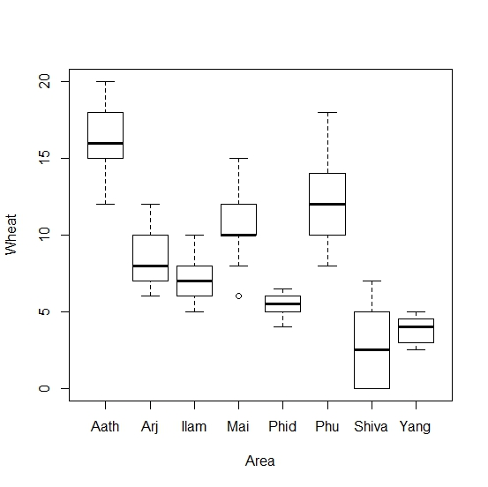
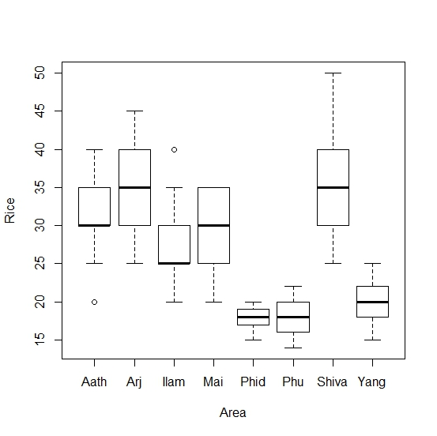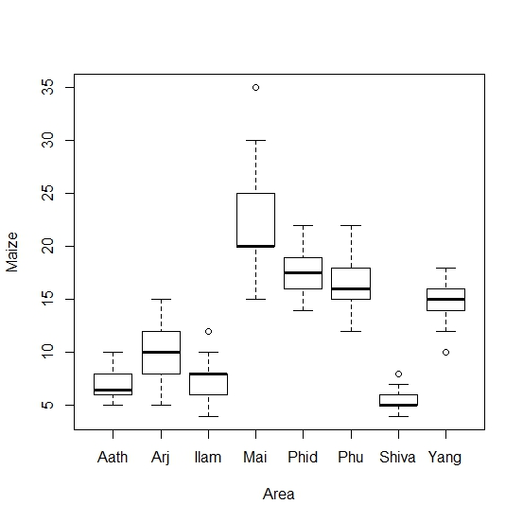
Figure 4: Accessibility of rice seeds through social network. Figure 5: Accessibility of maize seeds through social network.

Figure 6: shows accessibility of wheat seeds in study area.
Figure 6 shows quantitatively more accessibility of wheat seeds in individual household of Aathrai Triveni and least in Yangworak Rural Municipality.
Varietal suitability: There is significance high difference in the traditional seeds replacement in shivasatakhsi Municipality, Arjundhara Municipality, Aathrai Municipality, Yangworak Rural Municipality, Ilam Municipality, Phungling Municipality, Phidim Municipality respectively. However, insignificance difference in replacement rate of traditional rice seeds in household of Mai Rural Municipality. Traditional rice replacement in Phidim Municipality, Phungling Municipality and in Yangworak Rural Municipality have least traditional rice seeds replacement rate in individual household compared to other study area of agro-ecological belts.
Area | Estimate | t -value | P-value
Aathrai T. | 28.333 | 18.513 | < 2e-16 ***
Arjundhar | 28.333+ 44.000=72.333 | 20.329 | < 2e-16 ***
Ilam M. | 28.333+18.833 =46.666 | 8.702 | 6.15e-16 ***
Mai R. | 28.333+(8.167)=20.166 | -3.773 | 0.000205 ***
Phidim M. | 28.333+(-11.767)=11 | -5.437 | 1.37e-07 ***
Phungling M. | 28.333+(-17.333)=11 | -8.009 | 5.60e-14 ***
Shivasatakshi | 28.333+38.500=66.833 | 17.788 | < 2e-16 ***
Yangworak | 28.333+(-23.000)=5.333 | -10.627 | < 2e-16 ***
Table 3: Analysis of replacement rate of traditional rice seeds in individual household of agro ecological belt.
Table 4 there is high significance difference in the traditional maize seeds replacement in individual household of shivasatakhsi Municipality, Arjundhara Municipality, Ilam Municipality followed by Phidim Municipality, Aathrai Triveni Rural Municipality, Yangworak Rural Municipality, and Mai Rural Municipality respectively. However, insignificance difference in replacement rate of traditional Maize seeds found in household of Phungling Municipality.
Area | Estimate | t value | P-value
Aathrai T. | 2.8000 | 6.704 | 1.53e-10 ***
Arjundhar | 2.8000+7.8667=10.666 | 13.318 | < 2e-16 ***
Ilam M. | 2.8000+7.9333=10.733 | 13.431 | < 2e-16 ***
Mai R. | 2.8000+2.9667=5.766 | 5.023 | 1.02e-06 ***
Phidim M. | 2.8000+4.0667=6.866 | 6.885 | 5.36e-11 ***
Phungling M | 2.8000+0.2667 =3.066 | 0.451 | 0.652
Shivasatakhsi | 2.8000+5.4333 =8.233 | 9.199 | < 2e-16 ***
Yangworak | 2.8000+3.3000 =6.1 | 5.587 | 6.45e-08 ***
Table 4: Analysis of replacement rate of traditional maize seeds in agro ecological belts.
Table 5 traditional wheat seeds replacement in individual household of Aathrai Rural Municipality, followed by Mai Rural Municipality, Shivasatakshi Municipality, Yangworak Municipality, Phidim Municipality and Phungling Municipality, Arjundhara Municipality are significantly high. But, insignificance difference observed in Arjundhara Municipality and Ilam Municipality.
Area | Estimate | t -value | P-value
Aathrai | 14.333 | 12.629 | < 2e-16 ***
Arjundhara | 14.333+1.533=15.866 | 0.955 | 0.34040
Ilam M. | 14.333+5.100=19.433 | 3.178 | 0.00169 **
Mai R. | 14.333+12.433=26.766 | 7.747 | 2.92e-13 ***
Phidim M. | 14.333+6.700=21.033 | 4.174 | 4.23e-05 ***
Phungling | 14.333+8.333=22.663 | 5.192 | 4.54e-07 ***
Shivasatakshi | 14.333+(-9.600)=4.733 | -5.981 | 8.31e-09 ***
Yangworak | 14.333+(-9.033)=5.3 | -5.628 | 5.23e-08 ***
Table 5: Analysis of replacement rate of traditional wheat seeds in individual household of agro ecological belts.

Discussion
The more demand of improved varieties have replaced the traditional rice varieties due to its higher productivity. In Eastern development region 27 registered and 7 non registered varieties, in Central development region 32 registered and 4 non registered varieties, in Western development region 27 registered and 4 non registered, Mid-western development region has 30 registered and 2 non registered, in Far-western development region 22 registered & 2 non registered rice varieties have been reported. The cultivation of these varieties are due to high productivity (MOAD, 2015).
Improved maize seeds like Rampur composite, Arun-2, Manakamana -1, Manakaman-3 etc. are recommended by Government of Nepal. Similarly, Alrounder, Rajkumar Basha, Ganga etc are the Indian hybrid seeds planting by the farmer imported directly from the agro-vet without any recommendation of DADOs.The traditional maize seeds have lost due to un-planned commercialization and lack of conservation. The study in Ethopia shows that 7.5% of households have traditional maize varieties. About 63% of sample household have been using the improved varieties. The adoption of improved varieties is due to the higher rate of productivity and coping capacity with the changing climatic variability (Tura et al., 2010).
In Nepal about 97% of wheat cultivated area is covered by improved wheat varieties and only 3% of area is under local wheat varieties. The wheat seeds replacement rate is 14% in Nepal, which is lower than other south Asian countries. During the period between 2000 to 2017, wheat have some genetic gain especially linkage from Mexico (44%) and from India about 26 % (NARC, 2017).
Climatic impacts on seeds varieties: Biotech rice has higher productivity and more affordable, drought, salinity, pest resistance character. The development of drought resistance crops in China has higher priorities. By the end of 2030 approximately 235 million tone of paddy is annually produced equivalent to the one third of global production (Chen et al., 2011).The three major abiotic stresses like heat, drought and water logging are intolerable environmental factors for traditional crops. Coping with such abiotic stress requires genotypic variation of Maize. Such developed maize could be tolerance to flooding (Rathore et al., 2000).
Improved wheat varieties like Lerma 52, Annapurna-4 etc recommended to use in middle hill, RR-21,Nepal-297, WK-1204 etc are recommended to Terai and Gautam, NL 971 etc. are recommended to use in Terai, valley below 500 m (NARC, 2017). To cope the happening impact on wheat production, heat tolerant varieties like like DBW 14, DBW 16, RAJ 3765, GW 322 varieties are introduced in India on larger scales (Ray et al., 2015).
Seed sovereignty in agro-ecological belts: The availability of traditional rice seeds in sufficient quantity in Yangworak Rural Municipality without its abandonment. Shivasatakshi Municipality has conserved traditional rice but commercially un-registered rice varieties of India and improved recommended rice varieties have been tremendously adopting for production. Mai Rural Municipality, Ilam Municipality, Phidim Municipality, and Phungling Municipality have still traditional seeds sovereignty with loss of few traditional varieties and availability of improved rice varieties. However, household of Arjundhara Municipality have no Sovereignty over their traditional rice seeds.
There were high influences of improved and hybrid maize seeds in study area of agro-ecological belts. The individual household of Shivasatakshi Municipality, Mai R. Municipality, Phidim Municipality, Yangworak Rural Municipality, Phungling Municipality and Aathrai Triveni has availability of both traditional and modern Maize seeds. The influences of Improved and hybrid seeds have elevated indicating the decreasing quantity of traditional maize seeds in individual household i.e. gradually loosing traditional seeds sovereignty. Similarly, the study household of Arjundhara Municipality and Ilam Municipality have no a stock of traditional maize seeds means no traditional maize seeds sovereignty.
Individual household of Aathrai Triveni, Yangworak Rural Municipality and Phungling Municipality have availability of traditional wheat seeds. The availability of traditional wheat seeds in individual household of study area of Phidim Municipality, Ilam Municipality, Mai Rural Municipality, Arjundhara Municipality and Shivasatakshi Municipality have absolutely zero means no wheat seed sovereignty.

Varietal suitability: Traditional seeds replacement is based on adopting trend of modern seeds. Studied household of Arjundhara Municipality has no stock of rice seeds. Individual household of Arjundhara and Ilam Municipality have total replacement of traditional maize seeds means no traditional maize available. Similarly, except individual household of Aathrai Rural Municipality, Phungling Municipality and Yangworak Rural Municipality other five study area of agro-ecological belts has replacement of traditional wheat seeds. The seed replacement rate of paddy, maize and wheat in Nepal during the fiscal year 2008/09 are 5.99 %, 5.81 %, 6.85%. During 2009/2010 seed replacement rate are 6.55%, 5.98%% and 8.27 % for paddy, maize and wheat respectively. Similarly, seed replacement rate for paddy, maize and wheat during fiscal year 2010/2011 are 8.7%, 6.55% and 9.88% respectively (SQCC/NSB, 2010/11).

Conclusion & recommendation

Modern seeds have higher productivity compared to traditional seeds. Higher the productivity farmers have more attraction towards the modern seeds but it creates the challenges to the local seeds security. The modern seeds do not have quality like traditional seeds have. There were no big issue and influence of modern seeds before fourty years but now modern seeds have been using. The modern seeds are recommended because it has made by highly sophisticated system to cope the climatic variability and maintenance of higher productivity in specific geography.

Recommendation
- Community seeds bank should be established to conserve the traditional rice, maize and wheat seeds.
- Illegal trading of GMOs and hybrid seeds should be regulated in farm level & in market.

References:
Adhikari, J. (2014). Seed Sovereignty: Analysing the Debate on Hybrid Seeds and GMOs and Bringing About Sustainability in Agricultural Development. Journal of Forest and Livelihood.
D, B. (2017). Agriculture and Food Security under Climate Change in Nepal. Advances in Plants & Agriculture Research, 6(6). https://doi.org/10.15406/apar.2017.06.00237
Devkota, R. P. (2014). Climate Change: Trends and People’s Perception in Nepal. Journal of Environmental Protection, 05(04), 255–265. https://doi.org/10.4236/jep.2014.54029
Gauchan, D., Smale, M., Maxted, N., Cole, M., Sthapit, B. R., Jarvis, D., & Upadhyay, M. P. (2005). Socioeconomic and Agroecological Determinants of Conserving Diversity On-farm: The Case of Rice Genetic Resources in Nepal. Nepal Agriculture Research Journal, 6, 89–98. https://doi.org/10.3126/narj.v6i0.3370
Jarvis, D. I., Hodgkin, T., Sthapit, B. R., Fadda, C., & Lopez-Noriega, I. (2011). An Heuristic Framework for Identifying Multiple Ways of Supporting the Conservation and Use of Traditional Crop Varieties within the Agricultural Production System. Critical Reviews in Plant Sciences, 30(1–2), 125–176. https://doi.org/10.1080/07352689.2011.554358
Porcuna-Ferrer, A., Fiala, V., Freyer, B., Van Etten, J., Vernooy, R., & Probst, L. (2020). Do community seed banks contribute to the social-ecological resilience of communities? A case-study from western Guatemala. International Journal of Agricultural Sustainability, 18(3), 232–249. https://doi.org/10.1080/14735903.2020.1747199
Sunitha, G., Sunandini, G. P., Lavanya, T., & Reddy, D. S. (2025). Impact of Improved Red Gram Variety Adoption on Farmer Income and Economic Returns in Telangana, India. Journal of Experimental Agriculture International, 47(12), 298–305. https://doi.org/10.9734/jeai/2025/v47i123933
Thomas, M., Dawson, J. C., Goldringer, I., & Bonneuil, C. (2011). Seed exchanges, a key to analyze crop diversity dynamics in farmer-led on-farm conservation. Genetic Resources and Crop Evolution, 58(3), 321–338. https://doi.org/10.1007/s10722-011-9662-0

